*Florida International University*

*School of Computing and Information Sciences*

CIS 4911 - Senior Capstone Project

Software Engineering Focus

Feature Document

User Story #1023

**Team Member:**

Johnatan Jensen

**Product Owner(s)**:

Mohsen Taheri

**Mentor(s)**:

Mohsen Taheri

**Instructor**: Masoud Sadjadi

**User Story** **Create "Delete Account" option**

* As a User, I want to be able to delete my account, so I can remove myself from the database when I no longer want to use the VIP website.

**Acceptance Criteria**

* User is able to delete account
* Delete action is confirmed by user

**Use Case**

1. **User wishes to delete account to no longer be apart of the VIP database**   
   Participating Actors: Any user account type  
     
   Entry Condition: User accesses his/her profile page  
     
   Events Flow:
2. User scrolls to bottom of profile page
3. User clicks on “delete account” button
4. User is asked if they are sure
5. User confirms they are sure
6. User is notified they cannot reverse the action
7. User confirms they are knowledgeable
8. User account is deleted
9. Use case ends user is redirected to homepage with a no longer active account

**Use Case Diagram**

delete_account_use_case.png

**Sequence Diagram**

sequence_delete_story.png

**Class Diagram**

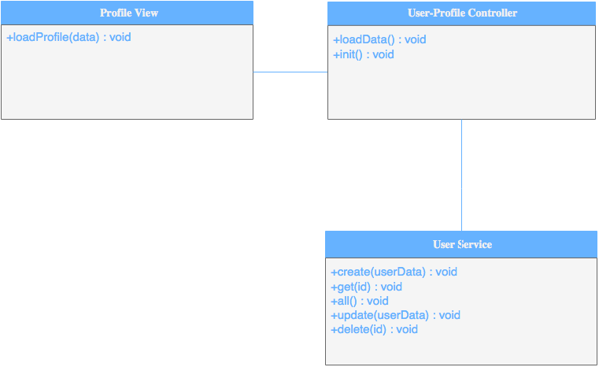

**Unit & Integration Tests**

* **Test Case 1 (Sunny)**
  + **Purpose:** Test that the user account is removed from the database
  + **Precondition:** User has accepted both confirmations that they wanted to delete their account
  + **Expected Result:** User is no longer in database and all their info is removed
  + **Actual Result:** User is no longer in database and all their info is removed
  + **Status: PASSED**
* **Test Case 2 (Rainy)**
  + **Purpose:** Test that the user can cancel at anytime before final confirmation their account will be safe
  + **Precondition:** User has pressed the “delete account” button
  + **Expected Result:** User can cancel at anytime and their account will not delete
  + **Actual Result:** User can cancel at anytime and their account will not delete
  + **Status: PASSED**

**Visual User Guide**

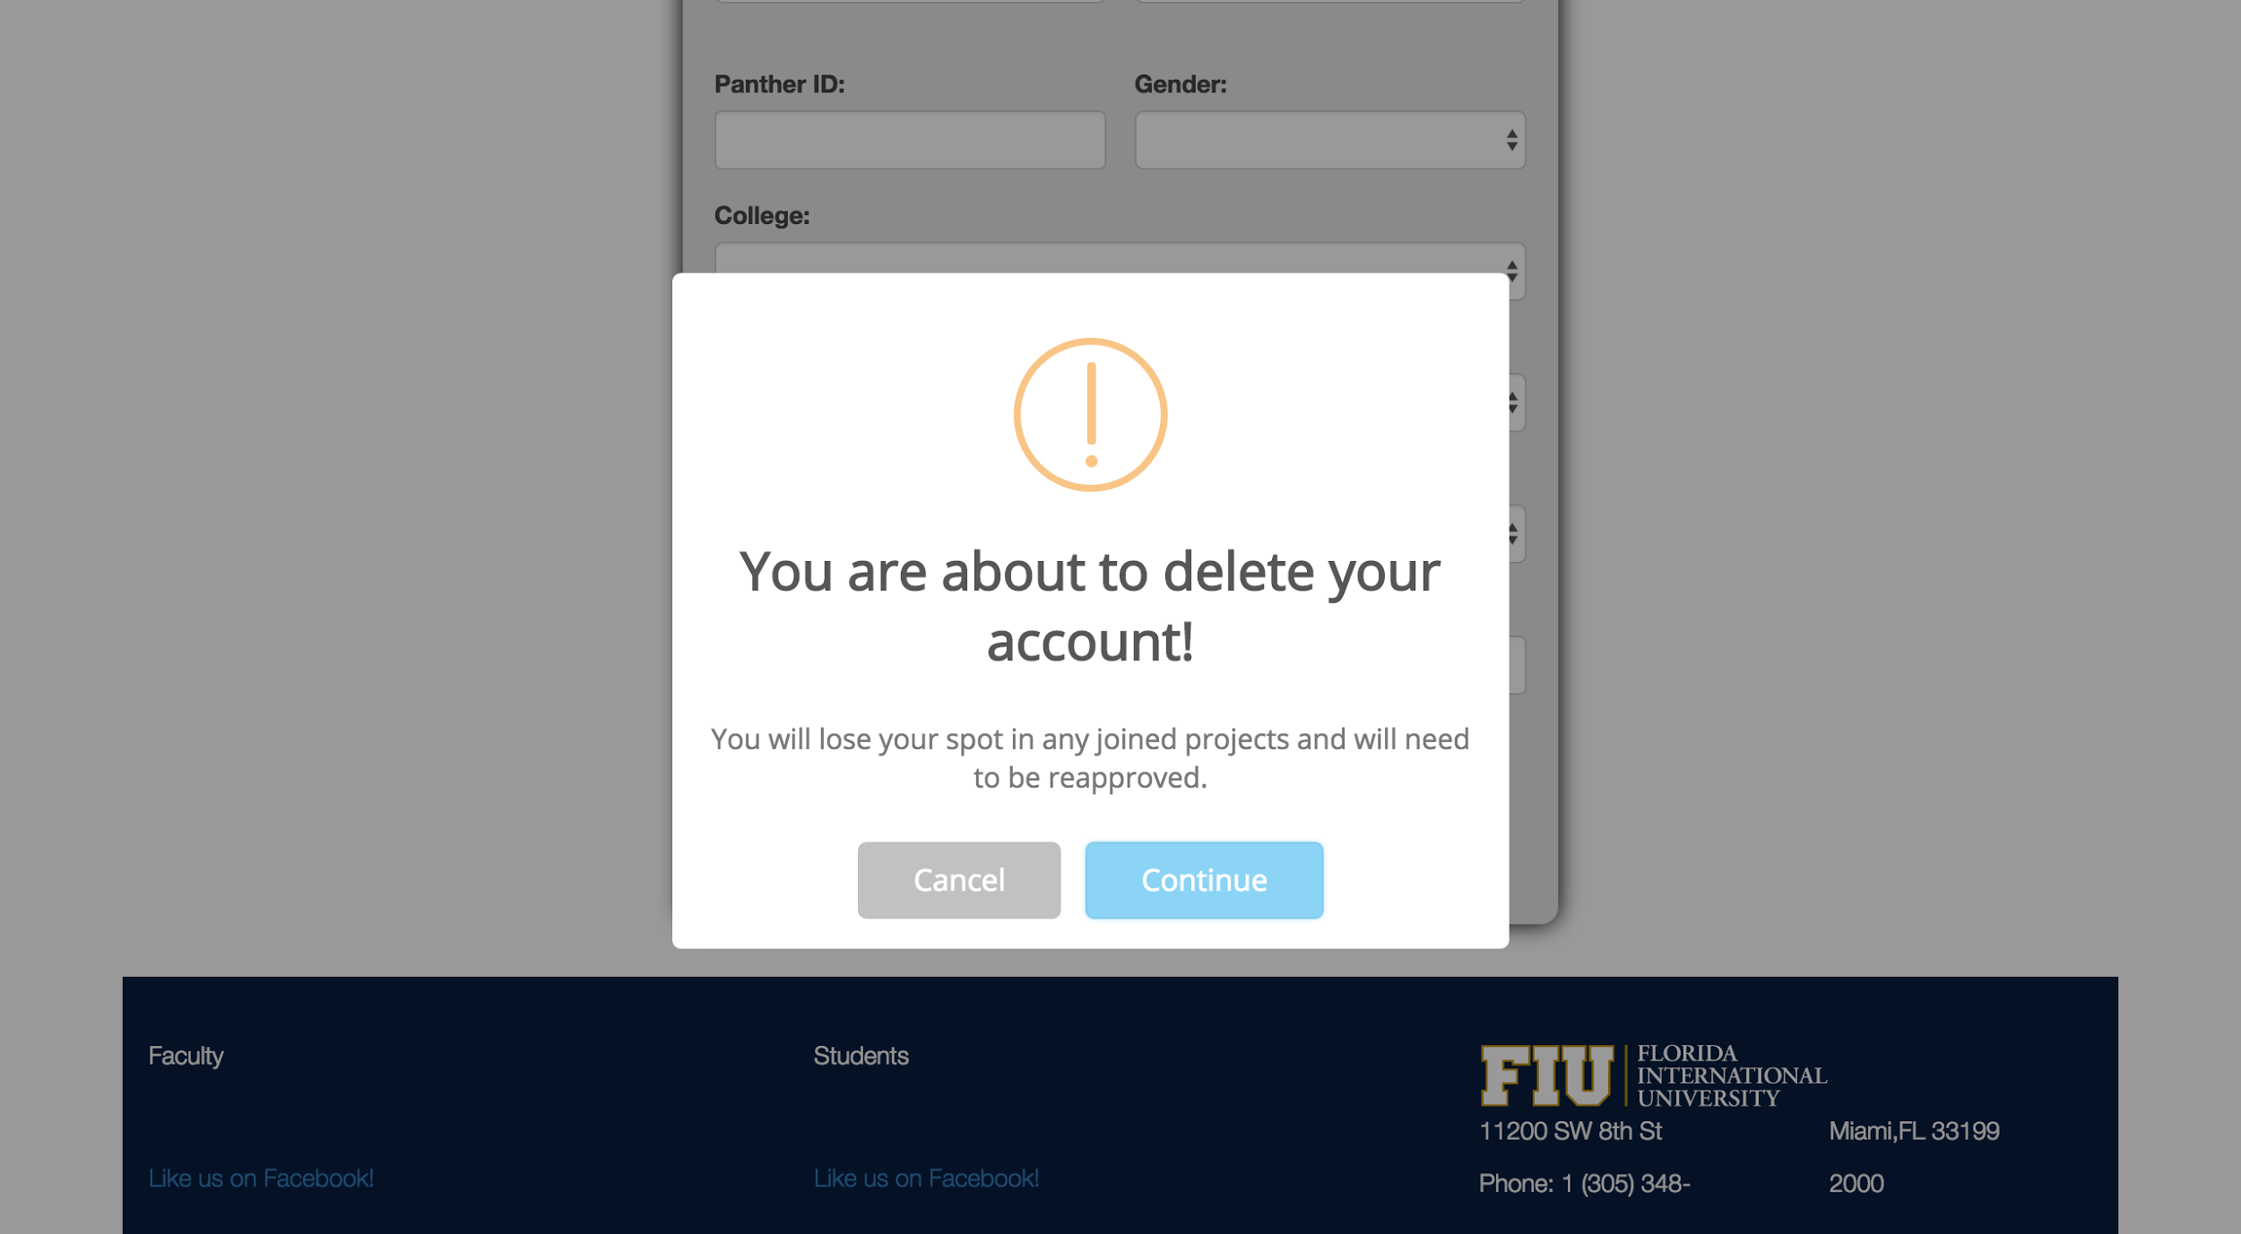

Confirmation box that user wishes to delete account

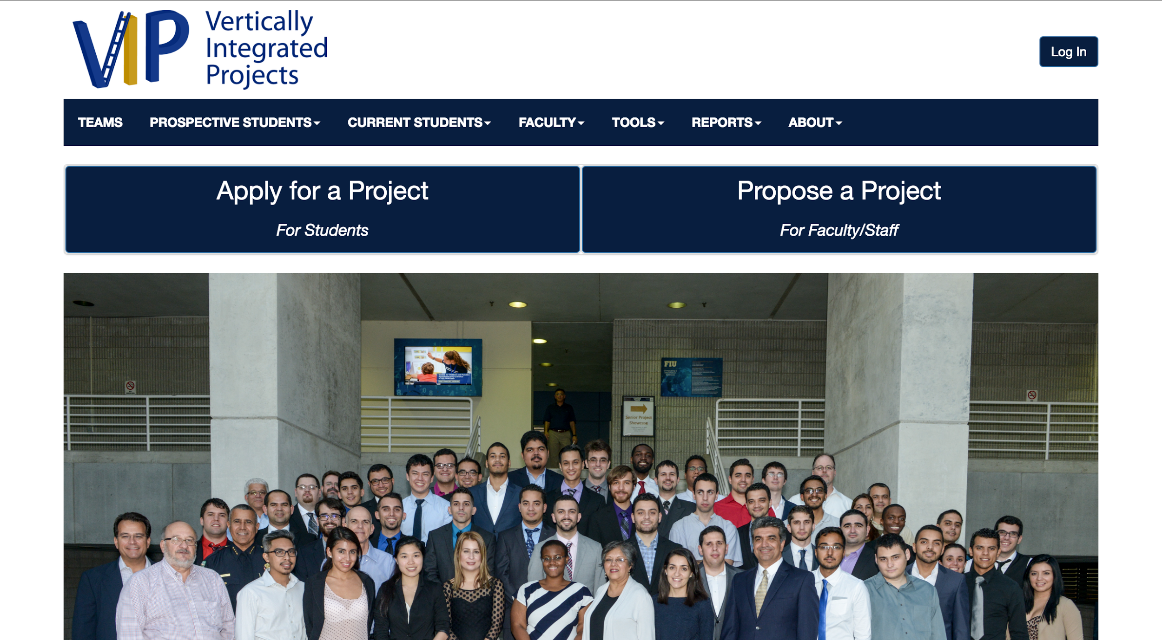

User is redirected to the homepage with no valid account after they confirm for the second time